Supplementary Table 1. Clinical baseline information on participants.
Variables | Total  (n = 1323) | Con  (n = 1012) | PPD  (n = 311) | U/x² | P
Age, n (%)
＜ 35 | 1127 (85.2) | 856 (84.6) | 271 (87.1) | 1.229 | 0.268
≥ 35 | 196 (14.8) | 156 (15.4) | 40 (12.9) | 1.229 | 0.268
Age of marriage,  m (Q1, Q3) | 27 (26,29) | 27 (26,29) | 27 (26,29) | 155928.500 | 0.806
Perinatal complications, n (%)
No | 300 (22.7) | 220 (21.7) | 80 (25.7) | 2.154 | 0.142
Yes | 1023 (77.3) | 792 (78.3) | 231 (74.3) | 2.154 | 0.142
History of abortion, n (%)
No | 971 (73.4) | 752 (74.3) | 219 (70.4) | 1.844 | 0.175
Yes | 352 (26.6) | 260 (25.7) | 92 (29.6) | 1.844 | 0.175
GDM, n (%)
No | 836 (63.2) | 630 (62.3) | 206 (66.2) | 1.624 | 0.203
Yes | 487 (36.8) | 382 (37.7) | 105 (33.8) | 1.624 | 0.203
PE, n (%)
No | 1275 (96.4) | 974 (96.2) | 301 (96.8) | 0.198 | 0.656
Yes | 48 (3.6) | 38 (3.8) | 10 (3.2) | 0.198 | 0.656
Assisted reproduction, n (%)
No | 1220 (92.2) | 938 (92.7) | 282 (90.7) | 1.342 | 0.247
Yes | 103 (7.8) | 74 (7.3) | 29 (9.3) | 1.342 | 0.247
Hypothyroidism, n (%)
No | 1149 (86.8) | 880 (87.0) | 269 (85.6) | 0.044 | 0.833
Yes | 174 (13.2) | 132 (13.0) | 42 (13.5) | 0.044 | 0.833
Five-color risk assessment, n (%)
Green | 292 (22.1) | 215 (21.2) | 77 (24.8) | 3.012 | 0.39
Yellow | 786 (59.4) | 612 (60.5) | 174 (55.9) | 3.012 | 0.39
Orange | 243 (18.4) | 184 (18.2) | 59 (19.0) | 3.012 | 0.39
Red | 2 (0.2) | 1 (0.1) | 1 (0.3) | 3.012 | 0.39
Delivery mode, n (%)
Spontaneous delivery | 776 (58.7) | 603 (59.6) | 173 (55.6) | 1.537 | 0.22
Cesarean section | 547 (41.3) | 409 (40.4) | 138 (44.4) | 1.537 | 0.22
Gestational week of delivery, n (%)
≥ 37 weeks | 1262 (95.4) | 965 (95.4) | 297 (95.5) | 0.011 | 0.916
＜ 37 weeks | 61 (4.6) | 47 (4.6) | 14 (4.5) | 0.011 | 0.916
Postpartum hemorrhage, n (%)
No | 1297 (98.0) | 996 (98.4) | 301 (96.8) | 3.298 | 0.069
Yes | 26 (2.0) | 16 (1.6) | 10 (3.2)
Blood type, n (%)
A | 396 (29.9） | 290 (28.7) | 106 (34.1) | 11.502 | 0.009
B | 384 (29.0) | 282 (27.9) | 102 (32.8) | 11.502 | 0.009
O | 433 (32.7) | 347 (34.3) | 86 (27.7) | 11.502 | 0.009
AB | 110 (8.3) | 93 (9.2) | 17 (5.5) | 11.502 | 0.009
Newborn sex, n (%)
Boy | 698 (52.8) | 533 (52.7) | 165 (53.1) | 0.014 | 0.905
Girl | 625 (47.2) | 479 (47.3) | 146 (46.9) | 0.014 | 0.905
Newborn weight, n (%)
＜ 1000g | 2 (0.2) | 1 (0.1) | 1 (0.3) | 1.921 | 0.589
1000g-2499g | 52 (3.9) | 38 (3.8) | 14 (4.5) | 1.921 | 0.589
2500g-3999g | 1220 (92.2) | 938 (92.7) | 282 (90.7) | 1.921 | 0.589
≥ 4000g | 49 (3.7) | 35 (3.5) | 14 (4.5) | 1.921 | 0.589
PSQI total score, m (Q1, Q3) | 6 (4,8) | 5 (3,7) | 8 (6,10) | 74710.500 | ＜0.0001
SSRS total score, m (Q1, Q3) | 40 (36,44) | 42 (38,45) | 36 (32,40) | 81900.000 | ＜0.0001
Abbreviations: Con, normal control group; PPD, Postpartum depression symptom group; U, Mann-Whitney U; x², Chi-square test; n, number; m, median; Q1, 25th percentile; Q3, 75th percentile; GDM, Gestational diabetes mellitus; PE, preeclampsia; SSRS, Social support Rating Scale; PSQI, Pittsburgh Sleep Quality Index.

Supplementary Table 2. Laboratory findings of participants.
Variables | Total  (n = 1323) | Con  (n=1012) | PPD  (n=311) | U/t | P
Blood count during postpartum period
White Blood Cell (×10⁹/L), m (Q1, Q3) | 6.67  (5.88,7.71) | 6.68  (5.86,7.75) | 6.62  (5.98,7.59) | 156250.00 | 0.850
Red Blood Cell (×10¹²/L), m (Q1, Q3) | 4.53  (4.30,4.75) | 4.52  (4.3,4.76) | 4.53  (4.30,4.73) | 155210.00 | 0.714
Hemoglobin (g/L), m (Q1, Q3) | 132  (127,138) | 132  (127,138) | 133  (127,138) | 154642.50 | 0.644
Hematocrit (%), m (Q1, Q3) | 40.40  (38.70,42.10) | 40.40  (38.70,42.10) | 40.40 (38.70,42.10) | 155898.50 | 0.803
Platelet Count (×10⁹/L), m (Q1, Q3) | 238  (205,277) | 237  (203,275) | 243  (207,282) | 147580.00 | 0.097
Neutrophil Percentage (%), m (Q1, Q3) | 57.60  (52.10,62.60) | 57.50 (52.00,62.60) | 58.00 (52.70,62.70) | 152765.00 | 0.435
Lymphocyte Percentage (%), mean ± SD | 33.65 (7.51) | 33.74 (7.58) | 33.37 (7.27） | 0.75 | 0.456
Monocyte Percentage (%), m (Q1, Q3) | 5.50  (4.70,6.40) | 5.50  (4.70,6.40) | 5.50  (4.70,6.40) | 156358.00 | 0.864
Eosinophil Percentage (%), m (Q1, Q3) | 2.30  (1.60,3.50) | 2.30  (1.60,3.50) | 2.40  (1.60,3.50) | 152486.00 | 0.407
Basophil Percentage (%), m (Q1, Q3) | 0.40  (0.30,0.50) | 0.40  (0.30,0.50) | 0.40  (0.30,0.50) | 147304.50 | 0.083
Neutrophil Count (×10⁹/L), m (Q1, Q3) | 3.83  (3.14,4.59) | 3.82  (3.12,4.65) | 3.86  (3.24,4.49) | 156749.00 | 0.917
Lymphocyte Count (×10⁹/L), m (Q1, Q3) | 2.23  (1.90,2.58) | 2.24  (1.91,2.59) | 2.21  (1.89,2.56) | 151409.50 | 0.312
Monocyte Count (×10⁹/L), m (Q1, Q3) | 0.37  (0.30,0.45) | 0.37  (0.3,0.45) | 0.37  (0.31,0.45) | 155324.00 | 0.729
Monocyte-to-Lymphocyte Ratio, m (Q1, Q3) | 0.17  (0.13,0.21) | 0.17  (0.13,0.21) | 0.17  (0.13,0.21) | 155228.50 | 0.717
Eosinophil Count  (×10⁹/L), m (Q1, Q3) | 0.16  (0.10,0.24) | 0.1  6 (0.10,0.24) | 0.16  (0.11,0.24) | 153445.50 | 0.506
Basophil Count  (×10⁹/L), m (Q1, Q3) | 0.02  (0.02,0.03) | 0.02  (0.02,0.03) | 0.03  (0.02,0.03) | 148107.00 | 0.105
Mean Corpuscular Volume (fL), m (Q1, Q3) | 89.40 (86.30,92.30) | 89.40 (86.10,92.30) | 89.50 (87.10,92.40) | 150672.50 | 0.256
Mean Corpuscular Hemoglobin (pg), m (Q1, Q3) | 29.40 (28.20,30.50) | 29.40 (28.20,30.50) | 29.40 (28.50,30.40) | 155956.50 | 0.811
Mean Corpuscular Hemoglobin Concentration (g/L), m (Q1, Q3) | 328  (322,334) | 328  (323,334) | 328  (321,334) | 149621.50 | 0.188
Red Cell Distribution Width-SD (fL), m (Q1, Q3) | 43.10 (41.10,46.00) | 43.10 (41.10,45.90) | 43.10 (41.10,46.20) | 154092.50 | 0.579
Red Cell Distribution Width-CV (%), m (Q1, Q3) | 13.00 (12.30,14.10) | 12.90 (12.30,14.10) | 13.00 (12.40,14.00) | 155034.50 | 0.692
Plateletcrit (%), m (Q1, Q3) | 0.22  (0.20,0.26) | 0.22  (0.20,0.26) | 0.23  (0.21,0.26) | 145082.00 | 0.037
Mean Platelet Volume (fL), m (Q1, Q3) | 9.40  (8.70,10.30) | 9.30  (8.70,10.20) | 9.40 (8.60,10.30) | 156498.00 | 0.883
Platelet Distribution Width (%), m (Q1, Q3) | 16.20 (15.90,16.50) | 16.20 (16.00,16.50) | 16.20 (15.90,16.50) | 157185.00 | 0.975
Platelet Larger Cell Ratio (%), m (Q1, Q3) | 22.40 (17.90,28.50) | 22.30 (17.90,28.50) | 22.60 (17.70,28.90) | 156920.00 | 0.940
Immature Granulocyte Percentage (%), m (Q1, Q3) | 0.10  (0.00,0.10) | 0.10  (0.00,0.10) | 0.10  (0.00,0.10) | 152312.50 | 0.357
Immature Granulocyte Count (×10⁹/L), m (Q1, Q3) | 0.01  (0.00,0.01) | 0.01  (0.00,0.01) | 0.01  (0.00,0.01) | 152790.50 | 0.396
Platelet-to-  Lymphocyte Ratio, m (Q1, Q3) | 106.45 (88.52,129.30) | 105.03 (86.21,128.07) | 113.71 (94.74,132.56) | 141340.00 | 0.007
Lymphocyte-to-  Monocyte Ratio, m (Q1, Q3) | 6.03  (4.79,7.50) | 6.04  (4.80,7.54) | 6.03  (4.77,7.41) | 155183.50 | 0.711
Neutrophil-to-  Lymphocyte Ratio, m (Q1, Q3) | 1.73  (1.36,2.18) | 1.71  (1.35,2.18) | 1.78  (1.38,2.18) | 151679.00 | 0.335
Liver and renal function, biochemical parameters during pregnancy
Total Calcium (mmol/L), m (Q1, Q3) | 2.17  (2.11,2.24) | 2.17  (2.11,2.24) | 2.17  (2.1,2.24) | 153733.50 | 0.537
Urea (mmol/L), m (Q1, Q3) | 3.56  (2.98,4.35) | 3.54  (2.96,4.30) | 3.66  (3.01,4.49) | 146300.00 | 0.060
Creatinine (μmol/L), m (Q1, Q3) | 41.90 (37.20,46.40) | 42.10 (37.50,46.40) | 41.00 (36.00,45.90) | 146980.50 | 0.078
Uric Acid (μmol/L), m (Q1, Q3) | 288.40 (245.00,331.80) | 287.75 (246.15,331.78) | 291.30 (244.20,332.80) | 156540.50 | 0.889
Total Protein (g/L), m (Q1, Q3) | 63.20 (60.60,65.80) | 63.20 (60.60,65.70) | 63.40 (60.50,66.00) | 152462.50 | 0.405
Albumin (g/L), m (Q1, Q3) | 35.90 (34.40,37.30) | 35.90 (34.40,37.30) | 35.80 (34.50,37.20) | 156399.00 | 0.870
Total Cholesterol (mmol/L), m (Q1, Q3) | 6.82  (6.09,7.71) | 6.85  (6.07,7.69) | 6.80  (6.15,7.87) | 154026.00 | 0.571
Triglycerides (mmol/L), m (Q1, Q3) | 2.98  (2.35,3.75) | 3.00  (2.37,3.78) | 2.92  (2.31,3.64) | 150509.00 | 0.245
Alanine Aminotransferase (U/L), m (Q1, Q3) | 10.10  (8.00,13.40) | 10.20 (8.00,13.30) | 10.00 (7.80,13.50) | 152233.00 | 0.384
Aspartate Aminotransferase (U/L), m (Q1, Q3) | 18.10 (15.90,20.80) | 18.10 (16.00,20.80) | 17.90 (15.90,20.90) | 151277.00 | 0.301
Alkaline Phosphatase  (U/L), m (Q1, Q3) | 148.30 (117.70,185.10) | 149.50 (118.70,188.50) | 143.20 (115.70,175.90) | 147100.50 | 0.082
Lactate Dehydrogenase (U/L), m (Q1, Q3) | 185.00 (165.00,205.10) | 186.25 (165.73,206.90) | 182.70 (163.80,198.80) | 146008.50 | 0.054
Gamma-Glutamyl Transferase (U/L), m (Q1, Q3) | 11.20  (8.70,15.30) | 11.30 (8.80,15.30) | 10.80 (8.50,15.10) | 149672.00 | 0.192
High-Density Lipoprotein (mmol/L), m (Q1, Q3) | 2.24 (1.97,2.55) | 2.24 (1.96,2.54) | 2.24 (2.00,2.57) | 152872.50 | 0.446
Low-Density Lipoprotein (mmol/L), m (Q1, Q3) | 3.59 (3.05,4.22) | 3.57 (3.04,4.21) | 3.62 (3.05,4.38) | 152656.50 | 0.424
Total Bilirubin (μmol/L), m (Q1, Q3) | 6.87 (5.6,8.72) | 6.89 (5.66,8.77) | 6.75 (5.38,8.56) | 147689.00 | 0.101
Direct Bilirubin (μmol/L), m (Q1, Q3) | 2.50 (2.07,3.01) | 2.51 (2.09,3.01) | 2.45 (2.02,3.03) | 152757.00 | 0.434
Total Bile Acids (μmol/L), m (Q1, Q3) | 2.10 (1.50,2.90) | 2.10 (1.50,2.90) | 2.20 (1.50,3.00) | 152210.00 | 0.381
Glucose (mmol/L), m (Q1, Q3) | 4.48 (4.24,4.76) | 4.47 (4.23,4.75) | 4.51 (4.26,4.80) | 151073.50 | 0.286
Homocysteine (μmol/L), m (Q1, Q3) | 6.37 (5.59,7.37) | 6.39 (5.61,7.36) | 6.32 (5.58,7.41) | 155811.50 | 0.792
Thyroid function during pregnancy
Thyroid-  Stimulating Hormone (mIU/L), m (Q1, Q3) | 1.95  (1.33,2.68) | 1.94  (1.35,2.61) | 1.97  (1.25,2.76) | 155899.00 | 0.803
Free Thyroxine (pmol/L), m (Q1, Q3) | 12.99  (11.80,14.10) | 13.00 (11.83,14.20) | 12.80 (11.80,13.90) | 147612.00 | 0.098
Thyroid Peroxidase Antibody (IU/mL), m (Q1, Q3) | 14.50  (10.20,20.90) | 14.70 (10.60,20.88) | 13.60 (9.00,21.00) | 146812.00 | 0.072
Abbreviations: Con, normal control group; PPD, Postpartum depression symptom group; U, Mann-Whitney U; t, Student's t-test; m, median; Q1, 25th percentile; Q3, 75th percentile; SD, Standard deviation.

Supplementary Table 3. Sociodemographic information of participants.
 | Total (n=1323) | Con (n=1012) | PPD (n=311) | x² | P
Marital status, n (%)
Be married | 1308 (98.9) | 1004 (99.2) | 304 (97.7) | 4.526 | 0.058*
Unmarried | 15 (1.1) | 8 (0.8) | 7 (2.3)
Self education level, n (%)
High school and below | 72 (5.4) | 49 (4.8) | 23 (7.4) | 3.697 | 0.158
Bachelor's degree or associate degree | 950 (71.8) | 726 (71.7) | 224 (72.0)
Master degree or above | 301 (22.8) | 237 (23.4) | 64 (20.6)
Education level of spouse, n (%)
High school and below | 85 (6.4) | 57 (5.6) | 28 (9.0) | 4.520 | 0.104
Bachelor's degree or associate degree | 901 (68.1) | 694 (68.6) | 207 (66.6）
Master degree or above | 337 (25.5) | 261 (25.8) | 76 (24.4)
Employed in regular positions, n (%)
Yes | 1043 (78.8) | 802 (79.2) | 241 (77.5) | 0.440 | 0.507
No | 280 (21.2) | 210 (20.8) | 70 (22.5)
Spouse employed in regular positions, n (%)
Yes | 1071 (81.0) | 819 (80.9) | 252 (81.0) | 0.002 | 0.969
No | 252 (19.0) | 193 (19.1) | 59 (19.0)
Nation, n (%)
Han | 1292 (97.7) | 987 (97.5) | 305 (98.1) | 0.015 | 0.581
National minority | 31 (2.3) | 25 (2.5) | 6 (1.9)
Religious belief, n (%)
No | 1252 (94.6) | 966 (95.5) | 286 (92.0) | 5.716 | 0.017
Yes | 71 (5.4) | 46 (4.5) | 25 (8.0)
Current working state, n (%)
Rest | 929 (70.2) | 700 (69.2) | 229 (73.6) | 2.266 | 0.132
Work | 394 (29.8) | 312 (30.8) | 82 (26.4)
Current working state of spouse, n (%)
Rest | 79 (6.0) | 59 (5.8) | 20 (6.4) | 0.153 | 0.696
Work | 1244 (94.0) | 953 (94.2) | 291 (93.6)
Smoking habit, n (%)
No | 1284 (97.1） | 991 (97.9) | 293 (94.2) | 11.462 | 0.001
Yes | 39 (2.9) | 21 (2.1) | 18 (5.8）
Smoking habit of spouse, n (%)
No | 850 (64.2) | 663 (65.5) | 187 (60.1) | 3.003 | 0.083
Yes | 473 (35.8) | 349 (34.5) | 124 (39.9)
Drinking habit, n (%)
No | 925 (69.9) | 723 (71.4) | 202 (65.0) | 4.765 | 0.029
Yes | 398 (30.1) | 289 (28.6) | 109 (35.0)
Drinking habit of spouse, n (%)
No | 415 (31.4) | 329 (32.5) | 86 (27.7) | 2.607 | 0.106
Yes | 908 (68.6) | 683 (67.5) | 225 (72.3)
Planned pregnancy, n (%)
Yes | 1047 (79.1) | 818 (80.8) | 229 (73.6) | 7.463 | 0.006
No | 276 (20.9) | 194 (19.2) | 82 (26.4)
Methods of conception, n (%)
Natural conception | 1212 (91.6) | 932 (92.1) | 280 (90.0) | 1.317 | 0.251
Artificial insemination | 111 (8.4) | 80 (7.9) | 31 (10.0)
Exercise during pregnancy, n (%)
Yes | 283 (21.4) | 195 (19.3) | 88 (28.3) | 11.528 | 0.001
No | 1040 (78.6) | 817 (80.7) | 223 (71.7)
Annual household income, n (%)
＜ ¥ 60,000 | 115 (8.7) | 79 (7.8) | 36 (11.6) | 6.143 | 0.189
¥ 60,000-100,000 | 124 (9.4) | 95 (9.4) | 29 (9.3)
¥ 100,000-150,000 | 232 (17.5) | 181 (17.9) | 51 (16.4)
¥ 150,000-200,000 | 302 (22.8) | 225 (22.2) | 77 (24.8)
＞¥ 200,000 | 550 (41.6) | 432 (42.7) | 118 (37.9)
Evaluation of the living environment, n (%)
Satisfaction | 1106 (83.6) | 921 (91.0) | 185 (59.5） | 172.717 | ＜0.0001
Average | 203 (15.3) | 86 (8.5) | 117 (37.6)
Dissatisfied | 14 (1.1) | 5 (0.5) | 9 (2.9)
Evaluation of marriage, n (%)
Blessedness | 1175 (88.8) | 940 (92.9) | 235 (75.6) | 73.925 | ＜0.0001
Average | 138 (10.4) | 69 (6.8) | 69 (22.2)
Unhappiness | 10 (0.8） | 3 (0.3) | 7 (2.3)
History of anxiety or depression, n (%)
No | 1304 (98.6) | 1006 (99.4) | 298 (95.8) | 21.626 | ＜0.0001
Yes | 19 (1.4) | 6 (0.6) | 13 (4.2)
Currently live with, n (%)
Spouse | 1252 (94.6) | 958 (94.7) | 294 (94.5) | 3.372 | 0.328*
Parents/in-laws | 61 (4.6) | 48 (4.7) | 13 (4.2)
Live alone | 7 (0.5) | 5 (0.5) | 2 (0.6)
Others | 3 (0.2) | 1 (0.1) | 2 (0.6)
Number of pregnancies, n (%)
1 | 851 (64.3) | 662 (65.4) | 189 (60.8) | 4.110 | 0.250*
2 | 302 (22.8) | 225 (22.2) | 77 (24.8)
3 | 108 (8.2) | 83 (8.2) | 25 (8.0)
≥4 | 62 (4.7) | 42 (4.2) | 20 (6.4)
Number of deliveries, n (%)
1 | 1089 (82.3) | 836 (82.6) | 253 (81.4) | 1.321 | 0.752*
2 | 216 (16.3) | 163 (16.1) | 53 (17.0)
3 | 16 (1.2) | 11 (1.1) | 5 (1.6)
≥4 | 2 (0.2) | 2 (0.2) | 0 (0.0)
Adverse maternal history, n (%)
No | 1139 (86.1) | 880 (87.0) | 259 (83.3) | 2.686 | 0.101
Yes | 184 (13.9) | 132 (13.0) | 52 (16.7)
Keeping pets during pregnancy, n (%)
No | 809 (61.1) | 623 (61.6) | 186 (59.8) | 0.308 | 0.579
Yes | 514 (38.9) | 389 (38.4) | 125 (40.2)
Exclusive breast feeding, n (%)
Yes | 471 (35.6) | 374 (37.0) | 97 (31.2) | 3.451 | 0.063
No | 852 (64.4) | 638 (63.0) | 214 (68.8)
Suffering emergancy events during pregnancy, n (%)
No | 1005 (76.0) | 841 (83.1) | 164 (52.7) | 120.168 | ＜0.0001
Yes | 318 (24.0) | 171 (16.9) | 147 (47.3)
Primary caregiver, n (%)
Spouse | 1223 (92.4) | 960 (94.9) | 263 (84.6) | 40.400 | ＜0.0001*
Parents/in-laws | 64 (4.8) | 34 (3.4) | 30 (9.6)
Friends/relatives | 23 (1.7) | 14 (1.4) | 9 (2.9)
No | 13 (1.0) | 4 (0.4) | 9 (2.9）
Caregivers preconception, n (%)
Spouse | 1289 (97.4) | 990 (97.9) | 299 (96.1) | 5.508 | 0.064
Parents/in-laws | 26 (2.0) | 15 (1.5) | 11 (3.5)
Friends/relatives | 7 (0.5) | 6 (0.6) | 1 (0.3)
Venting, n (%)
Initiative | 584 (44.1) | 499 (49.3) | 85 (27.3) | 77.334 | ＜0.0001*
For very close people | 603 (45.6) | 442 (43.7) | 161 (51.8)
When concerned | 108 (8.2) | 60 (5.9) | 48 (15.4)
Never | 28 (2.1) | 11 (1.1) | 17 (5.5)
Help-seeking behaviors, n (%)
Initiative | 1165 (88.1) | 933 (92.2) | 232 (74.6) | 75.767 | ＜0.0001*
Seldom | 135 (10.2) | 72 (7.1) | 63 (20.3)
Never | 23 (1.7) | 7 (0.7) | 16 (5.1)
Abbreviations: Con, normal control group; PPD, Postpartum depression symptom group; x², Chi-square test; n, number; *, Fisher exact test.

Supplementary Table 4. Performance metrics of the top 10 models based on basic machine learning algorithms in the training and test sets.
Model | AUC | Accuracy | Sensitivity | Specificity | PPV | NPV | PLR | NLR | F1 | Brier
Training
RF (SMOTE) | 0.965 | 0.916 | 0.863 | 0.932 | 0.796 | 0.957 | 12.701 | 0.147 | 0.829 | 0.091
RF (Weight) | 0.956 | 0.862 | 0.996 | 0.821 | 0.631 | 0.998 | 5.557 | 0.005 | 0.773 | 0.109
LGBM (SMOTE) | 0.944 | 0.894 | 0.755 | 0.937 | 0.787 | 0.926 | 11.977 | 0.261 | 0.770 | 0.083
Voting (Weight) | 0.925 | 0.874 | 0.651 | 0.943 | 0.779 | 0.898 | 11.442 | 0.370 | 0.709 | 0.100
XGBoost (Weight) | 0.920 | 0.840 | 0.855 | 0.836 | 0.616 | 0.949 | 5.203 | 0.173 | 0.716 | 0.112
CAT (Weight) | 0.917 | 0.833 | 0.835 | 0.832 | 0.605 | 0.943 | 4.969 | 0.198 | 0.702 | 0.145
GBM (SMOTE) | 0.913 | 0.857 | 0.711 | 0.902 | 0.691 | 0.910 | 7.279 | 0.320 | 0.701 | 0.103
XGBoost (SMOTE) | 0.906 | 0.856 | 0.723 | 0.897 | 0.684 | 0.913 | 7.046 | 0.309 | 0.703 | 0.108
KNN (SMOTE) | 0.903 | 0.761 | 0.863 | 0.729 | 0.495 | 0.946 | 3.190 | 0.187 | 0.630 | 0.147
CAT (SMOTE) | 0.898 | 0.851 | 0.715 | 0.892 | 0.672 | 0.910 | 6.647 | 0.319 | 0.693 | 0.111
Test
Voting (SMOTE) | 0.834 | 0.785 | 0.758 | 0.793 | 0.528 | 0.915 | 3.664 | 0.305 | 0.623 | 0.153
GLM (Weight) | 0.831 | 0.574 | 0.903 | 0.473 | 0.344 | 0.941 | 1.714 | 0.205 | 0.498 | 0.275
Voting (Weight) | 0.831 | 0.815 | 0.548 | 0.897 | 0.618 | 0.867 | 5.301 | 0.504 | 0.581 | 0.134
CAT (SMOTE) | 0.829 | 0.808 | 0.726 | 0.833 | 0.570 | 0.909 | 4.333 | 0.329 | 0.638 | 0.146
CAT (Weight) | 0.828 | 0.774 | 0.758 | 0.778 | 0.511 | 0.913 | 3.420 | 0.311 | 0.610 | 0.170
GLM (SMOTE) | 0.827 | 0.770 | 0.742 | 0.778 | 0.505 | 0.908 | 3.347 | 0.332 | 0.601 | 0.165
DL (SMOTE) | 0.826 | 0.762 | 0.710 | 0.778 | 0.494 | 0.898 | 3.201 | 0.373 | 0.583 | 0.167
XGBoost (Weight) | 0.825 | 0.758 | 0.677 | 0.783 | 0.488 | 0.888 | 3.125 | 0.412 | 0.568 | 0.160
GBM (SMOTE) | 0.824 | 0.808 | 0.677 | 0.847 | 0.575 | 0.896 | 4.436 | 0.381 | 0.622 | 0.144
ET (SMOTE) | 0.824 | 0.762 | 0.742 | 0.768 | 0.495 | 0.907 | 3.205 | 0.336 | 0.594 | 0.180

Abbreviation: RF, Random Forest; LGBM, Light Gradient Boosting Machine; XGBoost, eXtreme Gradient Boosting; CAT, Categorical Boosting; GBM, Gradient Boosting Machine; KNN, K-Nearest Neighbors; GLM, Generalized Linear Model; DL, Deep Learning; ET, Extremely Randomized Trees; SMOTE, Synthetic Minority Oversampling Technique; Weight, Sample Weight; Voting, Voting Ensemble Model; AUC, Area Under the Receiver-Operating Curve; PPV, positive predictive value; NPV, negative predictive value; PLR, positive likelihood ratio; NLR, negative likelihood ratio.

Supplementary Table 5. Performance metrics of the top 10 machine learning models based on a stacking strategy in the training and test sets.
Model | AUC | Accuracy | Sensitivity | Specificity | PPV | NPV | PLR | NLR | F1 | Brier
Training
GLM (Weight)+RF (Weight) | 0.857 | 0.846 | 0.542 | 0.939 | 0.734 | 0.870 | 8.951 | 0.487 | 0.624 | 0.158
Voting Top5+GLM (Weight) | 0.856 | 0.844 | 0.534 | 0.939 | 0.731 | 0.868 | 8.819 | 0.496 | 0.617 | 0.157
Voting Top5+GLM (Weight)+RF (Weight) | 0.855 | 0.842 | 0.530 | 0.938 | 0.725 | 0.866 | 8.577 | 0.501 | 0.613 | 0.157
Voting Top5+GLM (Weight)+CAT (Weight) | 0.855 | 0.847 | 0.510 | 0.951 | 0.760 | 0.863 | 10.316 | 0.515 | 0.611 | 0.156
Voting Top3+GLM (Weight)+CAT (Weight)+RF (Weight) | 0.855 | 0.846 | 0.518 | 0.947 | 0.750 | 0.865 | 9.747 | 0.509 | 0.613 | 0.156
Voting Top5+Voting Top3+GLM (Weight)+XGBoost (Weight) | 0.855 | 0.846 | 0.514 | 0.948 | 0.753 | 0.864 | 9.902 | 0.513 | 0.611 | 0.156
Voting Top5+GLM (Weight)+CAT (Weight)+XGBoost (Weight)+RF (Weight) | 0.855 | 0.846 | 0.498 | 0.953 | 0.765 | 0.860 | 10.602 | 0.527 | 0.603 | 0.155
GLM (Weight)+CAT (Weight) | 0.855 | 0.842 | 0.510 | 0.944 | 0.738 | 0.862 | 9.169 | 0.519 | 0.603 | 0.156
Voting Top3+GLM (Weight)+CAT (Weight) | 0.855 | 0.844 | 0.514 | 0.946 | 0.744 | 0.863 | 9.452 | 0.514 | 0.608 | 0.156
GLM (Weight)+CAT (Weight)+RF (Weight) | 0.855 | 0.846 | 0.514 | 0.948 | 0.753 | 0.864 | 9.902 | 0.513 | 0.611 | 0.156
Test
Voting Top5+XGBoost (Weight) | 0.835 | 0.808 | 0.484 | 0.906 | 0.612 | 0.852 | 5.170 | 0.569 | 0.541 | 0.162
Voting Top5+GLM (Weight) | 0.833 | 0.800 | 0.484 | 0.897 | 0.588 | 0.850 | 4.677 | 0.576 | 0.531 | 0.162
Voting Top3+CAT (Weight) | 0.833 | 0.808 | 0.468 | 0.911 | 0.617 | 0.849 | 5.275 | 0.584 | 0.532 | 0.161
Voting Top3+CAT (Weight)+RF (Weight) | 0.833 | 0.808 | 0.468 | 0.911 | 0.617 | 0.849 | 5.275 | 0.584 | 0.532 | 0.162
Voting Top5+CAT (Weight) | 0.833 | 0.811 | 0.468 | 0.916 | 0.630 | 0.849 | 5.585 | 0.581 | 0.537 | 0.161
Voting Top3+GLM (Weight)+XGBoost (Weight)+RF (Weight) | 0.833 | 0.804 | 0.468 | 0.906 | 0.604 | 0.848 | 4.997 | 0.587 | 0.527 | 0.162
Voting Top3+CAT (Weight)+XGBoost (Weight) | 0.833 | 0.808 | 0.484 | 0.906 | 0.612 | 0.852 | 5.170 | 0.569 | 0.541 | 0.161
Voting Top5+Voting Top3+RF (Weight) | 0.833 | 0.808 | 0.468 | 0.911 | 0.617 | 0.849 | 5.275 | 0.584 | 0.532 | 0.162
Voting Top5+CAT (Weight)+XGBoost (Weight)+RF (Weight) | 0.833 | 0.808 | 0.468 | 0.911 | 0.617 | 0.849 | 5.275 | 0.584 | 0.532 | 0.162
Voting Top3+XGBoost (Weight) | 0.832 | 0.800 | 0.468 | 0.901 | 0.592 | 0.847 | 4.748 | 0.590 | 0.523 | 0.161
Abbreviation: GLM, Generalized Linear Model; RF, Random Forest; CAT, Categorical Boosting; XGBoost, eXtreme Gradient Boosting; SMOTE, Synthetic Minority Oversampling Technique; Weight, Sample Weight; Voting, Voting Ensemble Model; AUC, Area Under the Receiver-Operating Curve; PPV, positive predictive value; NPV, negative predictive value; PLR, positive likelihood ratio; NLR, negative likelihood ratio.

Supplementary Table 6. Performance metrics of the top 5 models in the training set.
Model | AUC | Accuracy | Sensitivity | Specificity | PPV | NPV | PLR | NLR | F1 | Brier
RF (SMOTE) | 0.965 | 0.916 | 0.863 | 0.932 | 0.796 | 0.957 | 12.701 | 0.147 | 0.829 | 0.091
RF (Weight) | 0.956 | 0.862 | 0.996 | 0.821 | 0.631 | 0.998 | 5.557 | 0.005 | 0.773 | 0.109
LGBM (SMOTE) | 0.944 | 0.894 | 0.755 | 0.937 | 0.787 | 0.926 | 11.977 | 0.261 | 0.770 | 0.083
Voting (Weight) | 0.925 | 0.874 | 0.651 | 0.943 | 0.779 | 0.898 | 11.442 | 0.370 | 0.709 | 0.100
XGBoost (Weight) | 0.920 | 0.840 | 0.855 | 0.836 | 0.616 | 0.949 | 5.203 | 0.173 | 0.716 | 0.112
Abbreviation: RF, Random Forest; LGBM, Light Gradient Boosting Machine; XGBoost, eXtreme Gradient Boosting; SMOTE, Synthetic Minority Oversampling Technique; Weight, Sample Weight; Voting, Voting Ensemble Model; AUC, Area Under the Receiver-Operating Curve; PPV, positive predictive value; NPV, negative predictive value; PLR, positive likelihood ratio; NLR, negative likelihood ratio.

Supplementary Table 7. Multivariable logistic regression analysis.
Variables | B | Wald | OR | OR (95%CI) |  | P
 |  |  |  | lower | upper | P
PSQI total score  (Z scorce) | 0.897 | 87.079 | 2.453 | 2.031 | 2.961 | ＜0.0001
SSRS total score  (Z scorce) | -0.579 | 37.82 | 0.56 | 0.466 | 0.674 | ＜0.0001
Mean Corpuscular Volume (Z scorce) | 0.28 | 5.801 | 1.323 | 1.053 | 1.661 | 0.016
Platelet Count  (Z scorce) | 0.139 | 2.653 | 1.149 | 0.972 | 1.357 | 0.103
Suffering emergency events during pregnancy
No |  |  | Ref
Yes | 1.138 | 42.86 | 3.121 | 2.22 | 4.388 | ＜0.0001
Smoking habit
No |  |  | Ref
Yes | 0.791 | 3.43 | 2.206 | 0.955 | 5.097 | 0.064
Exercise during pregnancy
No |  |  | Ref
Yes | -0.389 | 4.151 | 0.677 | 0.466 | 0.985 | 0.042
Venting
Initiative |  |  | Ref
For very close people | 0.23 | 1.549 | 1.258 | 0.876 | 1.807 | 0.213
When asked | 0.898 | 9.47 | 2.456 | 1.386 | 4.353 | 0.002
Never | 0.486 | 0.755 | 1.625 | 0.544 | 4.859 | 0.385
Living environment
Satisfaction |  |  | Ref
Average | 1.37 | 48.106 | 3.935 | 2.672 | 5.795 | ＜0.0001
Dissatisfied | 0.139 | 0.046 | 1.149 | 0.325 | 4.064 | 0.829
Primary caregiver
Spouse |  |  | Ref
Parents/in-laws | 0.338 | 0.984 | 1.401 | 0.719 | 2.73 | 0.321
Friends/relatives | -0.419 | 0.499 | 0.658 | 0.206 | 2.102 | 0.48
No | 1.359 | 1.816 | 3.893 | 0.539 | 28.102 | 0.178
Blood Type
AB |  |  | Ref
A | 0.366 | 1.075 | 1.442 | 0.722 | 2.881 | 0.3
B | 0.385 | 1.174 | 1.469 | 0.733 | 2.946 | 0.279
O | -0.053 | 0.022 | 0.948 | 0.469 | 1.917 | 0.882
Abbreviations: PSQI, Pittsburgh Sleep Quality Index; SSRS, Social Support Rating Scale; OR, odds ratio; CI, confidence interval; Ref, Reference.

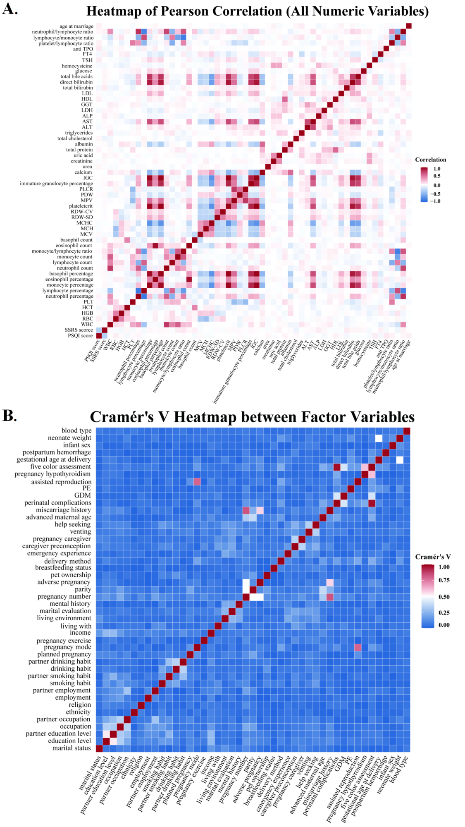
Supplementary Fig. 1. Heat map of correlation analysis of all feature factors. (A) Correlation analysis of continuous numerical variables; (B) Correlation analysis of categorical variables.
Abbreviation: IGC, immature granulocyte count; MCH, mean corpuscular hemoglobin; MCHC, mean corpuscular hemoglobin concentration; MPV, mean platelet volume; MCV, mean corpuscular volume; PLT, platelet count; PLCR, platelet large cell ratio; GDM, gestational diabetes mellitus; PSQI, Pittsburgh Sleep Quality Index; SSRS, Social Skills Rating System; RDW-SD, Red Cell Distribution Width - Standard Deviation; PDW, platelet distribution width; ALT, alanine aminotransferase; AST, aspartate aminotransferase; ALP, alkaline phosphatase; TPO, thyroid peroxidase; TSH, thyroid-stimulating hormone; FT4, free thyroxine; HDL, high-density lipoprotein; G-GT, gamma-glutamyl transferase; LDH, lactate dehydrogenase; HGB, hemoglobin; WBC, white blood cell count; RBC, red blood cell count.

Supplementary Fig. 2. Top 20 GVIF values by numerical variables.
Abbreviation: MPV, mean platelet volume; PLCR, platelet large cell ratio; AST, aspartate aminotransferase; WBC, white blood cell count.

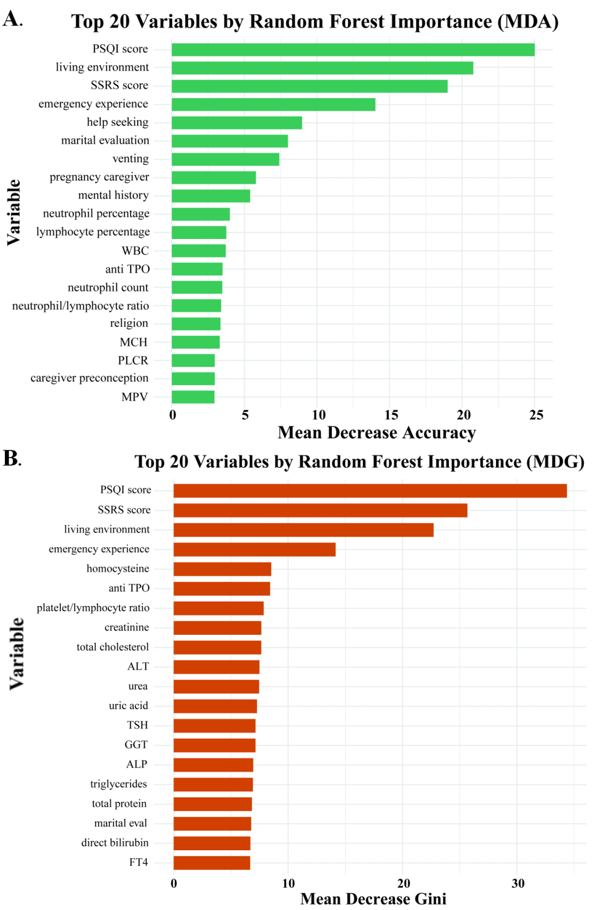
Supplementary Fig. 3. Top 20 factors selected by Random Forest. (A) Top 20 factors selected by mean decrease in accuracy; (B) Top 20 factors selected by mean decrease in Gini.
Abbreviation: PSQI, Pittsburgh Sleep Quality Index; SSRS, Social Skills Rating System; MPV, mean platelet volume; PLCR, platelet large cell ratio; ALT, alanine aminotransferase; ALP, alkaline phosphatase; TPO, thyroid peroxidase; FT4, free thyroxine; TSH, thyroid-Stimulating hormone; GGT, gamma-glutamyl transferase; WBC, white blood cell count.

Supplementary Fig. 4. Top 20 factors selected by XGBoost.
Abbreviation: PSQI, Pittsburgh Sleep Quality Index; SSRS, Social Skills Rating System; TPO, thyroid peroxidase; HDL, high-density lipoprotein; TSH, thyroid-Stimulating hormone; AST, aspartate aminotransferase; ALP, alkaline phosphatase; LDH, lactate dehydrogenase; MCV, mean corpuscular volume; RDW-SD, Red Cell Distribution Width - Standard Deviation; GGT, gamma-glutamyl transferase; ALT, alanine aminotransferase.

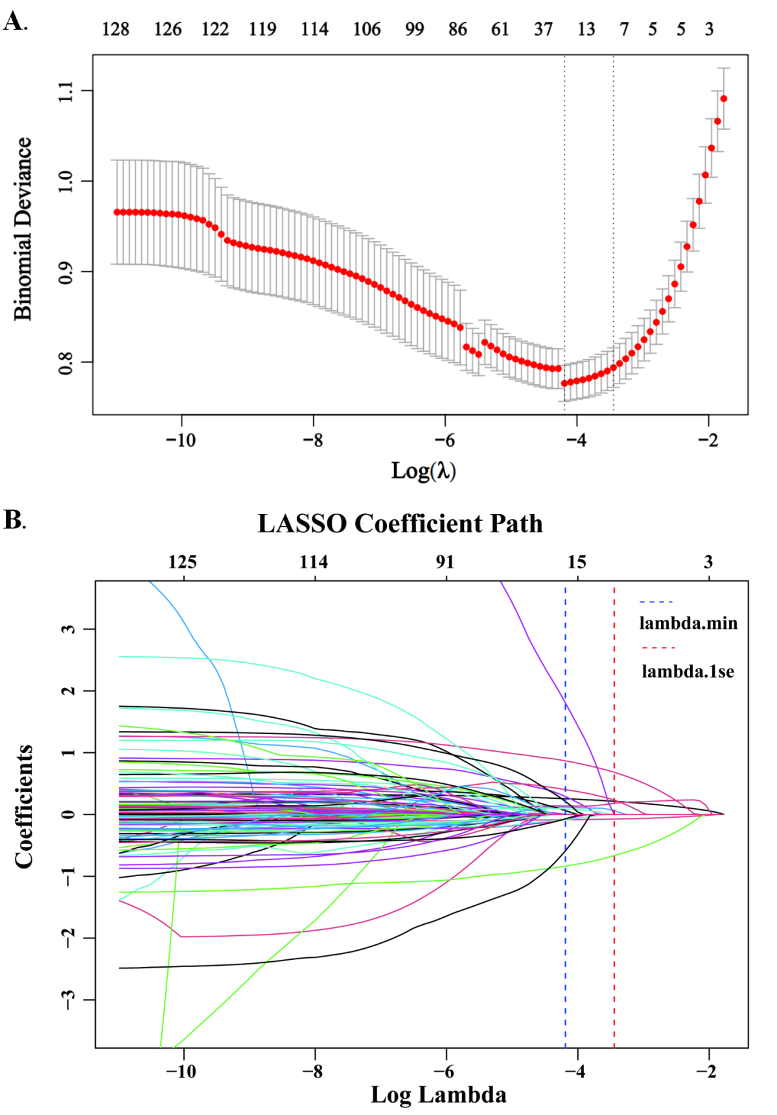

Supplementary Fig. 5. Selection of candidate predictors via the LASSO‑logistic regression model. (A) Selection of adjustment parameters (λ) in the Lasso model using ten-fold cross-validation based on minimum criteria; (B) Regression coefficient plot for predictor variables with different penalty parameters (λ).

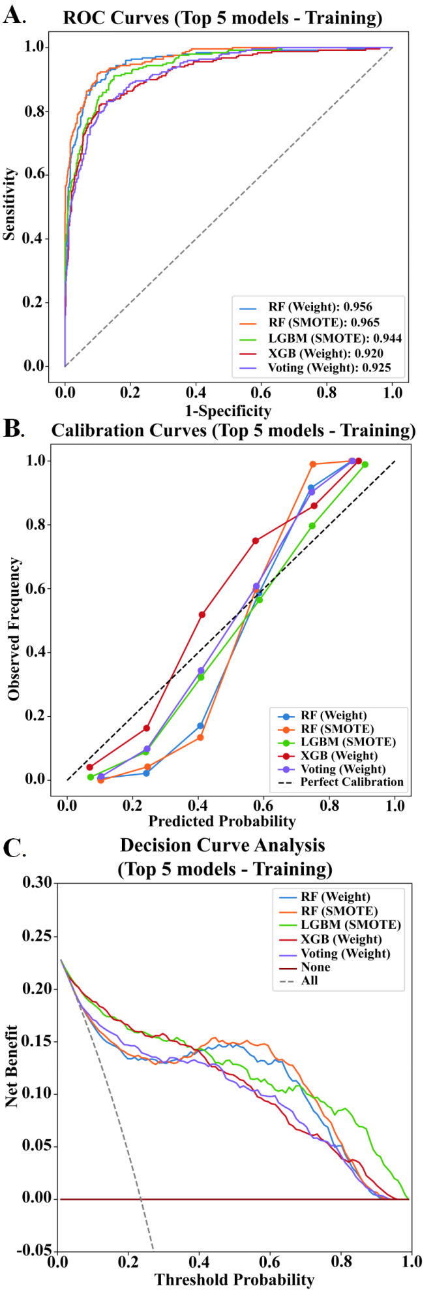
Supplementary Fig. 6. ROC curves, calibration curves and decision curves analysis (DCA) of PPD models of the training set. (A). ROC curves of the top 5 models. (B) Calibration curves of the top 5 models. (C) Decision curve analysis of the top 5 models..
Supplementary Fig. 7. Clinical impact curve of PPD models. (A) Clinical impact curve of training set; (B) Clinical impact curve of test set.

Supplementary Fig. 8. Nomogram of important feature factors.

Supplementary Fig. 9. Impact of sample size on model performance.
Abbreviation: XGB, eXtreme Gradient Boosting.

